Java Lab -6

Praneesh R V

CB.SC.U4CYS23036

Qn1,

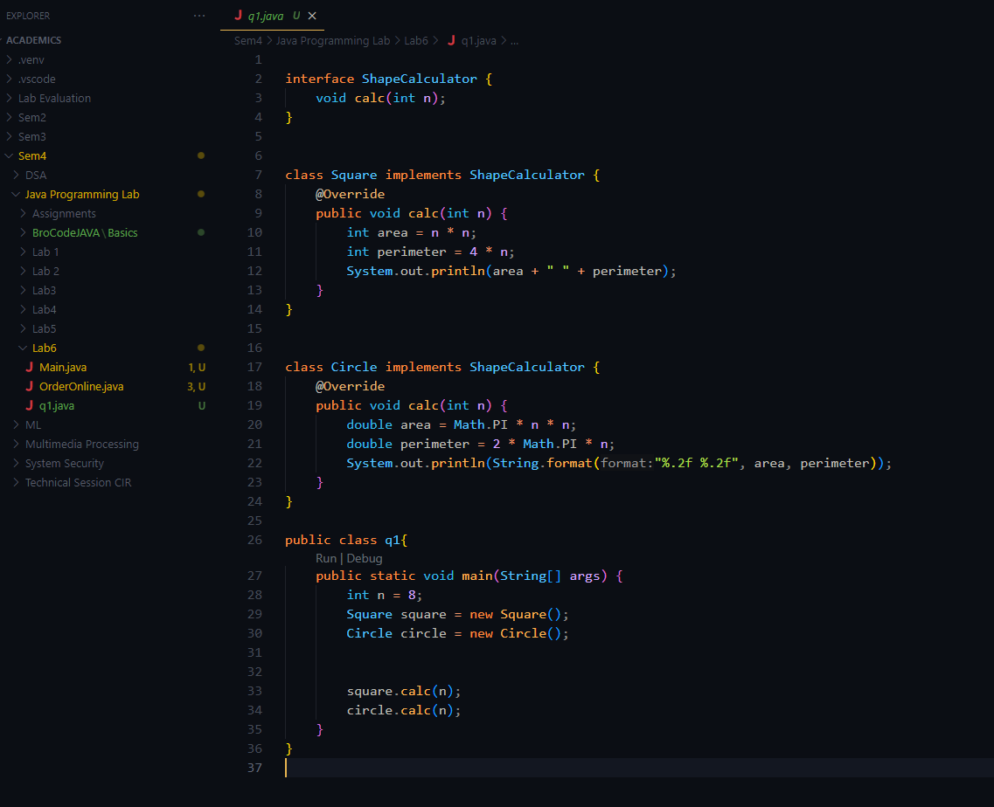

Output:

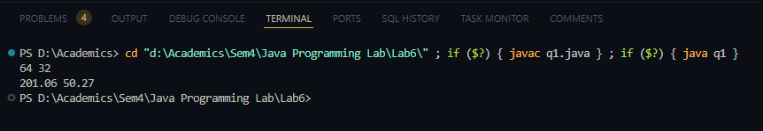

Qn2,

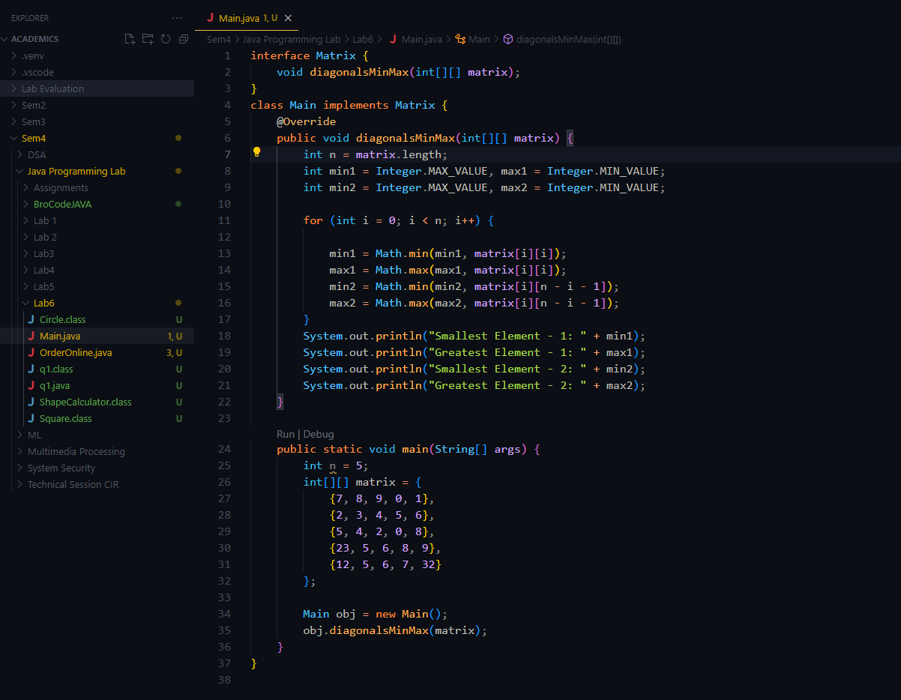

Output:

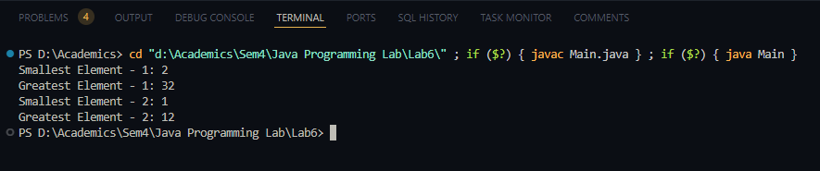

Qn3,

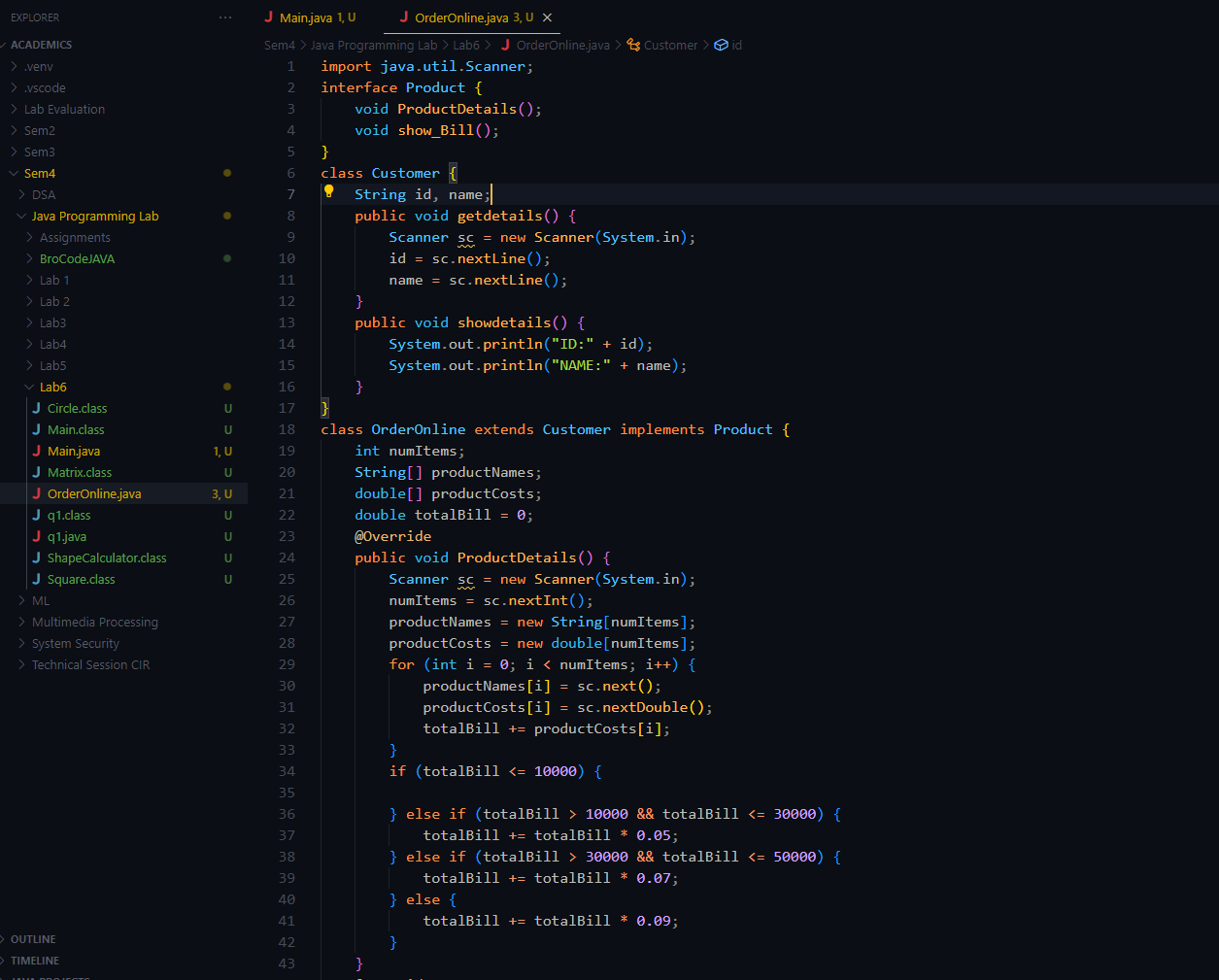

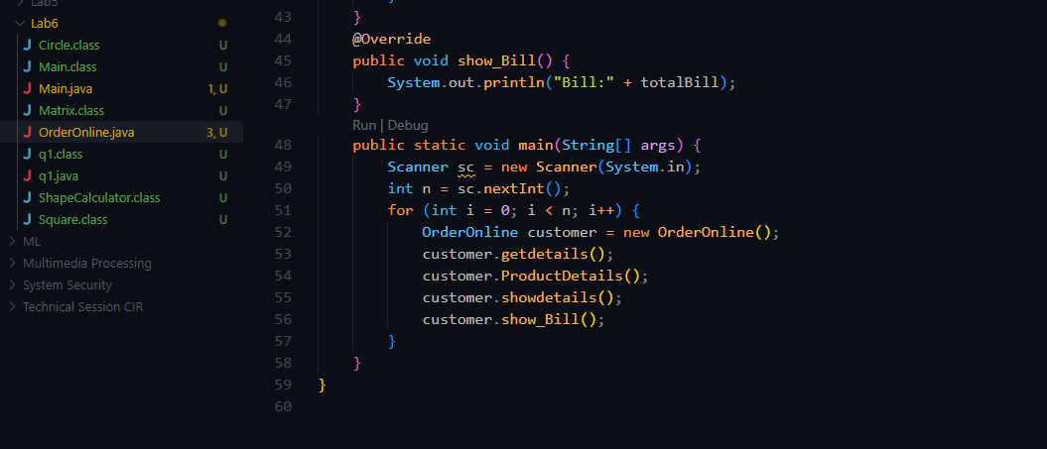

Output:

